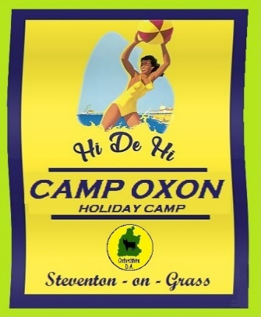 |  | Camp Oxon  Oxfordshire D.A.  August 26th – 29th 2022
Friday
4.00pm | Put the Marquee up
7.30pm | Friday night is music night
Saturday
10.00am | Keep Fit outside your unit
3:00pm | Baby Competition
3.30pm | Baby Games
7.30pm | Bingo with a twist
8.00pm | Fancy Dress competition
8.30pm | American Supper
9:00pm | Games
Sunday
10.00am | Keep Fit outside your unit
3.00pm | Miss Oxfordshire
3.30pm | Team Games
7.30pm | Bingo with a twist
8.00pm | The really bad talent show
Monday
9:00am | Dismantle the Marquee
10:30am | Bacon Butties with the Chairman
11:00am | Closing Ceremony and raffle

