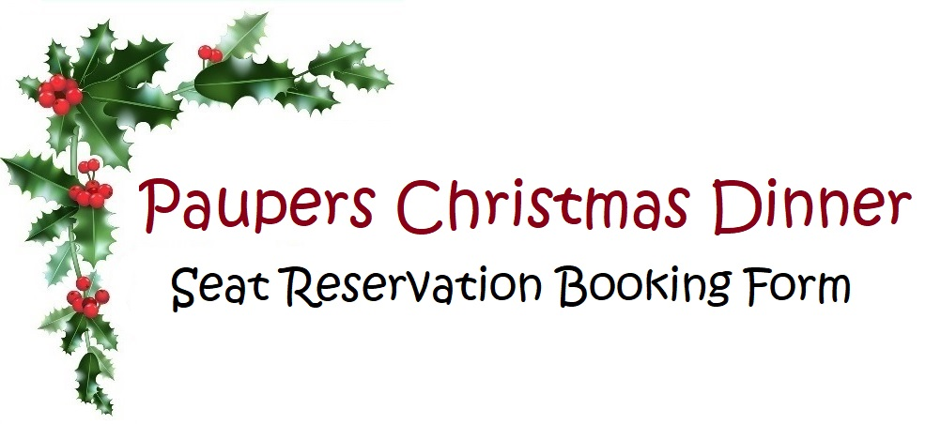

Name: …………………………………………………………..

Address: ……………………………………………………….

Membership No: ………………………………………….

D.A.: …………………………………………………………….

Number of Adults: ……………………………………….

Number of Children: (please include name and age for secret Santa) …………………………………………………………………………

Any dietary requirements: ………………………………

…………………………………………………………………………

Seat Reservation: £5 per person

Please send your deposit with this form to

L. Simmonds, Vale Croft, Lane End, Lower Tysoe, Warwickshire CV35 0BZ

This books your place at the Paupers Christmas Dinner meet. Your site fees will be adjusted accordingly when you attend